Daniel Komac

CPE 185: Introduction to Microprocessors

Lab Session: Wednesday

**Lab 1: x86**

Instructor: Chris Moyer

Date: November 17th, 2015

**Introduction:**

The purpose of this lab was to introduce us to the Intel x86 architecture. This lab consisted of 3 parts using DOS in a windows 98VM. The virtual machine was needed to access MASM as well, using DOS allowed us to debug in assembly language and work on hardware level.

**Part 1: Debug and C refresher:**

**Purpose:**

Understanding how to use DOS Debug and getting us re-familiarized with a programming language that is very important in programming many of the boards that we work with such as Arduino or Propeller.

**Analysis:**

Within the DOS window we are able to use DOS commands that show us useful data. But in order to learn the commands first we use the help command which is used in DOS’s debug mode

First we enter Debug:

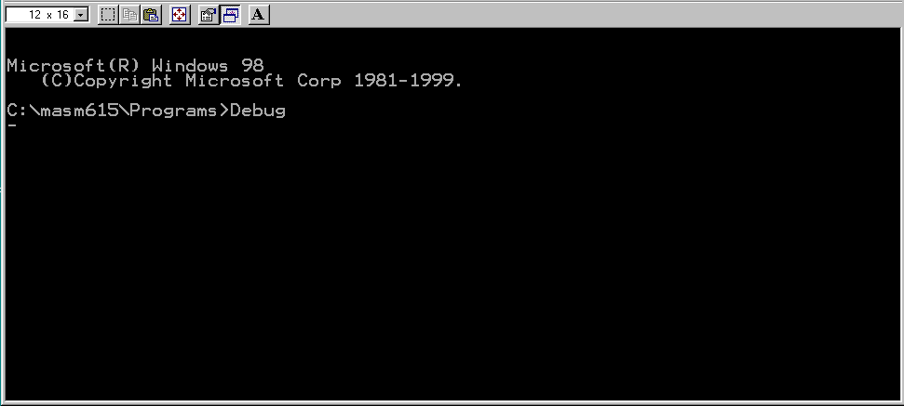

Then the dump command to see what is in memory at the moment.

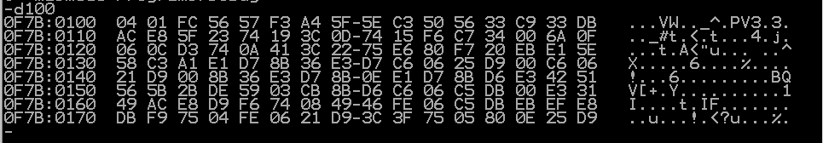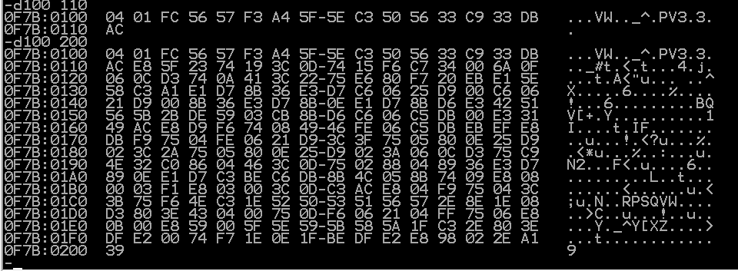

After finding out what we have in our memory we edit the memory segment of 0100 to 0118 with the e(enter) command



After we entered our data we were able to unassembled the program and see how it works

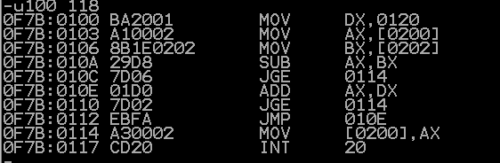

After that we check the value of our registers to see if we are in the right place



All our registers are clear and we are on the first line of code, so now we will trace the program with the t command.



I executed this program twice with different values. These were my results

